Solution worksheet 03

Ilia, Dudnik [ilia.dudnik@fau.de](mailto:ilia.dudnik@fau.de)

Mader, Benedikt [benedikt.mader@fau.de](mailto:benedikt.mader@fau.de)

Ganzmann, Tobias [tobias.ganzmann@fau.de](mailto:tobias.ganzmann@fau.de)

Aakash Ram, Chandran [aakash.chandran@fau.de](mailto:aakash.chandran@fau.de)

Problem 1

a) Given: 𝝀 = 0.75

µ = 1

The average values for: -

**utilization (U)** = 𝝀 /µ = 0.75/1 = 0.75

**number of customers in the system (N)** = U/(1-U) = 0.75/0.25 = 3

**throughput (X):** Since the system is stable (µ > 𝝀), then departure rate = arrival rate.

X = 𝝀 = m*U*µ, where m is the number of servers in the system.

X = 1*0.75*1 = 0.75

**time spent in the system (D)** = N /X = 3/0.75 = 4

b) How do the measures D and N change for a simple M/D/1 queue with the same arrival rate and identical mean service time as the M/M/1 queue above?

D = $\frac{U (c_{s}^{2}+1)}{2μ(1-U)}+\frac{1}{μ}$ = $\frac{0.75 (0+1)}{2*1(1-0.75)}+\frac{1}{1}$ = 1.5 +1 = 2.5

N = X*D = 0.75*2.5 = 1.875

D and N both have decreased values in M/D/1 than in M/M/1.

Problem 2

b) Values from simulation for time averaged expectation of N(t) = 1.875 and the expectation of D(i) = 2.5 from the Statistics objects are same as the values from problem 1

с) Values both for MM1 and MD1 seem to be correctly calculated.

MM1:

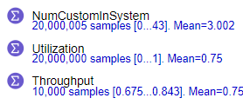 

MD1:

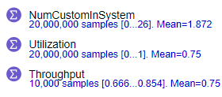



d) for MD1:  
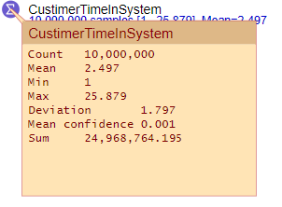

we have mean of 2.5 and deviation of 1.8

for MM1:

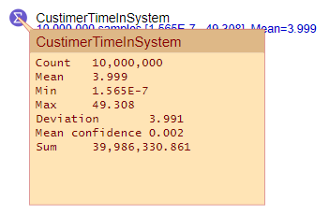

Which is definitely exponential distribution because we have mean of 4 and deviation of 4, which in turn means that coef of variation equals 1.